**Business Report: Hotel Booking Data Analysis**

**Assumptions:**

1. Prices may influence reservation cancellations.

2. Longer waiting lists might lead to higher cancellation rates.

3. Offline travel agents are the primary source of reservations.

4. Customer preferences vary based on room types and amenities.

5. External factors like economic trends may impact booking patterns.

**Research Questions:**

1. What factors impact hotel reservation cancellations?

2. How can hotel reservation cancellations be reduced?

3. How can pricing and promotional strategies be optimized?

**Hypotheses:**

1. Higher prices correlate with increased reservation cancellations.

2. Longer waiting lists result in higher cancellation rates.

3. Offline travel agents contribute the most to reservation bookings.

4. Specific room types and sought-after amenities may affect cancellation rates.

5. Economic downturns might lead to an elevated number of booking cancellations.

**Insights:**

**1. Cancellation Percentage Distribution:**

- Not Cancelled: 62.87%

- Cancelled: 37.13%

**2. Cancellation Percentage Distribution (Resort Hotel):**

- Not Cancelled: 72.03%

- Cancelled: 27.97%

**3. Cancellation Percentage Distribution (City Hotel):**

- Not Cancelled: 58.29%

- Cancelled: 41.71%

**4. Market Segment Distribution:**

- Online TA: 56,402

- Offline TA/TO: 24,160

- Groups: 19,806

- Direct: 12,448

- Corporate: 5,111

- Complementary: 734

- Aviation: 237

**5. Market Segment Distribution (Normalized):**

- Online TA: 47.44%

- Offline TA/TO: 20.32%

- Groups: 16.66%

- Direct: 10.47%

- Corporate: 4.30%

- Complementary: 0.62%

- Aviation: 0.20%

**6. Market Segment Distribution (Cancelled Reservations):**

- Online TA: 20,738

- Groups: 12,097

- Offline TA/TO: 8,278

- Direct: 1,920

- Corporate: 978

- Complementary: 90

- Aviation: 52

**7. Market Segment Distribution (Cancelled Reservations - Normalized):**

- Online TA: 46.97%

- Groups: 27.40%

- Offline TA/TO: 18.75%

- Direct: 4.35%

- Corporate: 2.22%

- Complementary: 0.20%

- Aviation: 0.12%

**Graphs:**

**1. Reservation Status Count.**

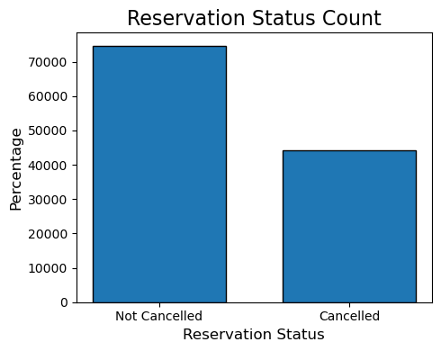

**2. Reservation status in different hotels.**

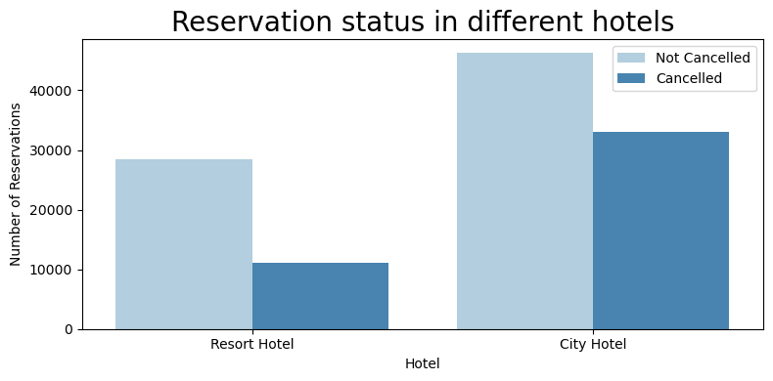

**3. Average daily rate in City and Resort Hotel.**

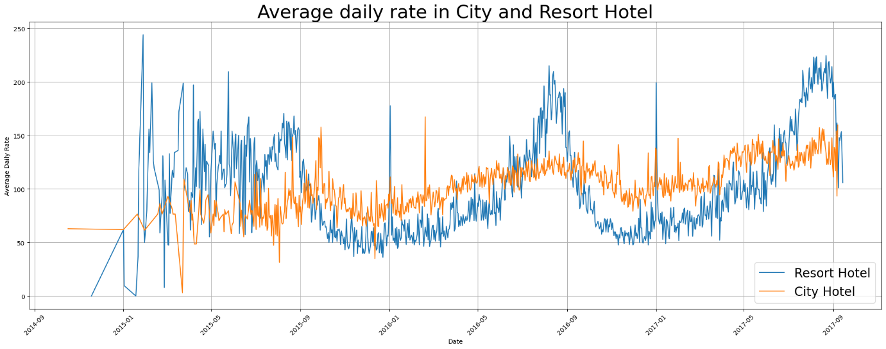

**4. Reservation status per month.**

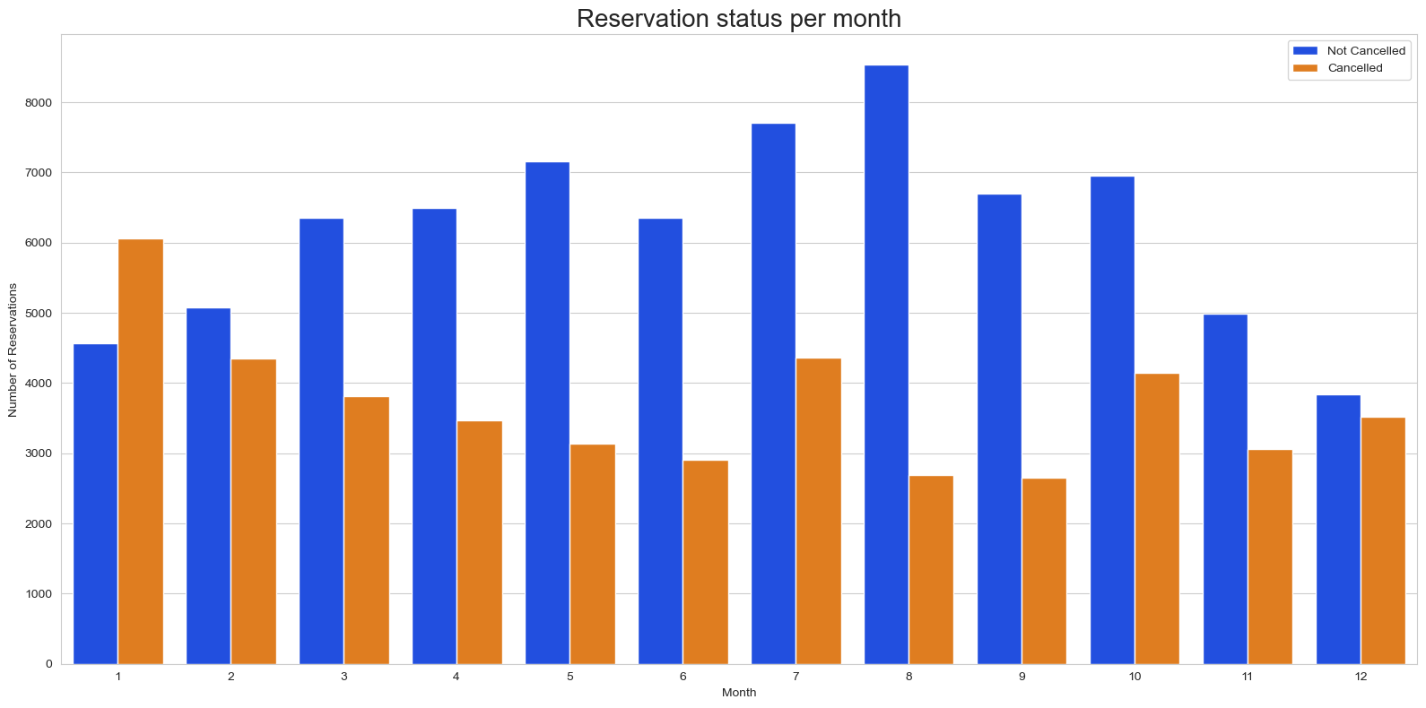

**4. Average Daily Rate per month.**

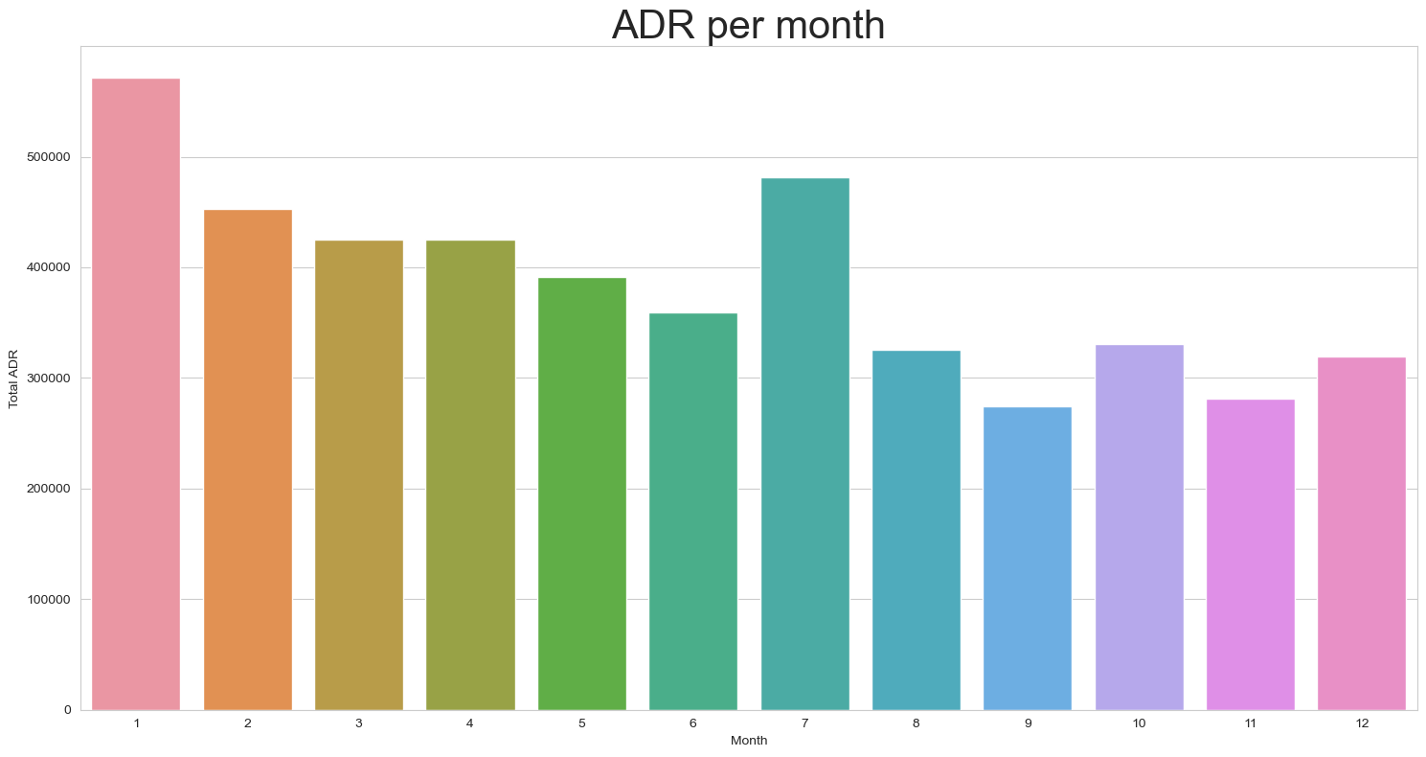

**4. Top 10 countries with reservation cancellation.**

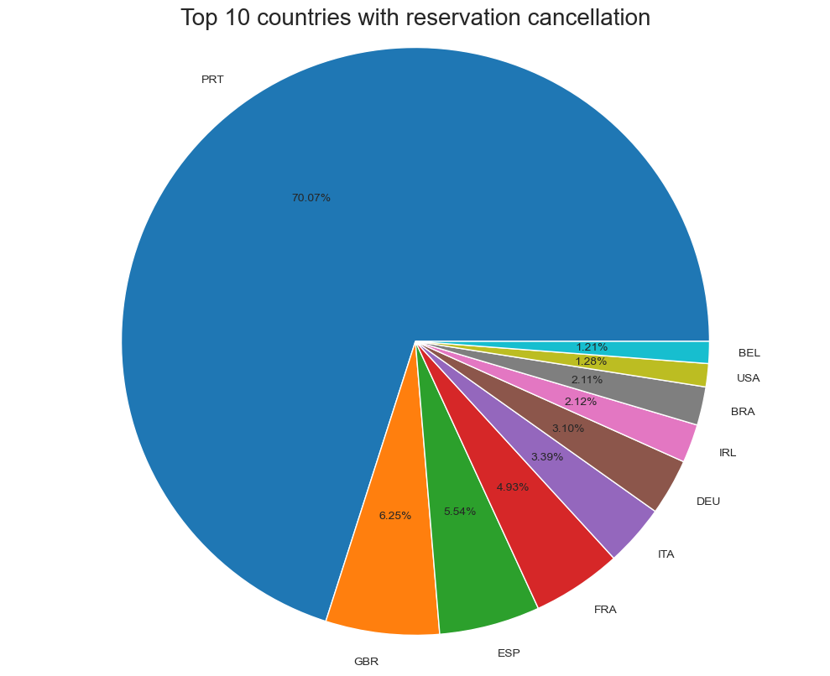

**5. Average Daily Rate.**

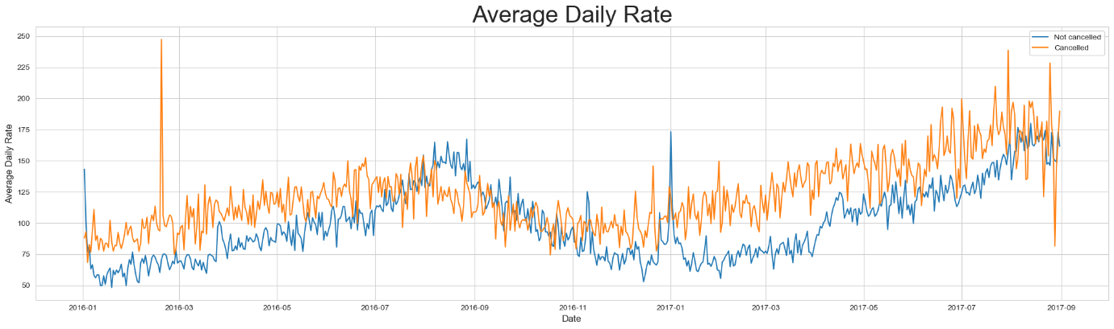

**Suggestions:**

1. Implement dynamic pricing strategies to optimize revenue and reduce cancellations.

2. Manage waiting lists efficiently to minimize cancellations due to delays.

3. Collaborate with offline travel agents for targeted promotional campaigns.

4. Customize room offerings based on guest preferences to enhance satisfaction.

5. Monitor economic trends and adjust strategies to mitigate booking cancellations.

**Conclusion:**

In conclusion, this analysis provides valuable insights into the factors influencing reservation cancellations in the hotel industry. By addressing pricing strategies, waiting lists, collaborating with travel agents, tailoring room offerings, and staying attuned to economic shifts, hotels can not only improve efficiency and revenue generation but also ensure enhanced guest experiences and sustainable profitability.